EXPERIMENT – 4
AIM:
To create a simple cloud-based Car Booking Reservation System using a Cloud Service Provider to demonstrate the Software as a Service (SaaS) model.
PROCEDURE:
- A cloud service provider platform is selected to design and deploy the application as Software as a Service (SaaS).
- A cloud application named “Car Booking Reservation System” is created to manage car booking operations online.
- A Car Details module is designed to store information about available cars for booking.
- A Customer Details module is created to maintain customer information required for reservations.
- A Booking module is implemented to allow customers to book cars by selecting car and customer details.
- Dropdown fields are configured to ensure consistent and error-free data entry.
- Lookup fields are used to link car details and customer details with booking records.
- All booking information is stored securely in the cloud and can be accessed by authorized users through a web browser.
- The application is deployed on the cloud without requiring any local software installation.
- The system successfully demonstrates the SaaS model, where the cloud provider manages infrastructure, maintenance, and updates.
RESULTS:
1.
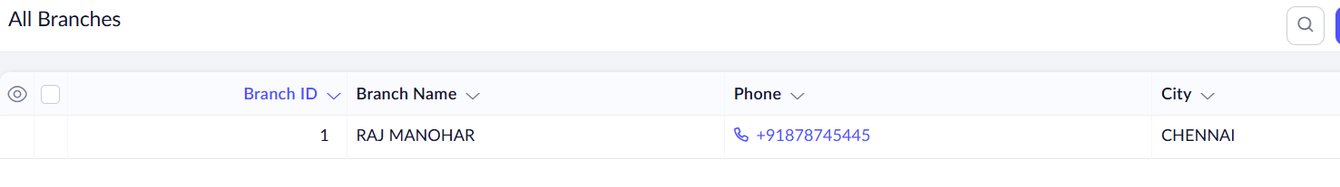
2. 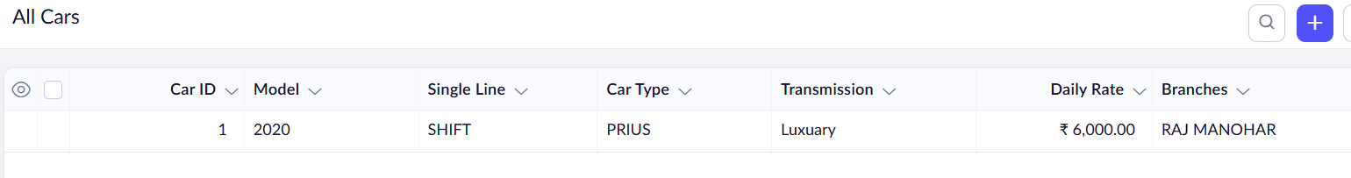
3.
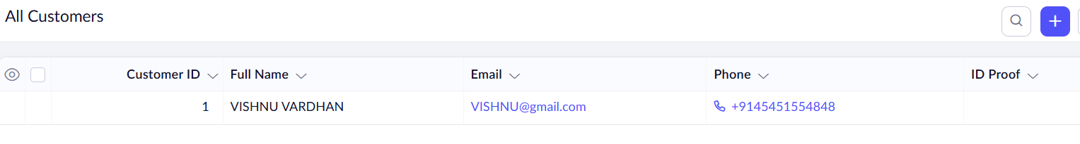
4. 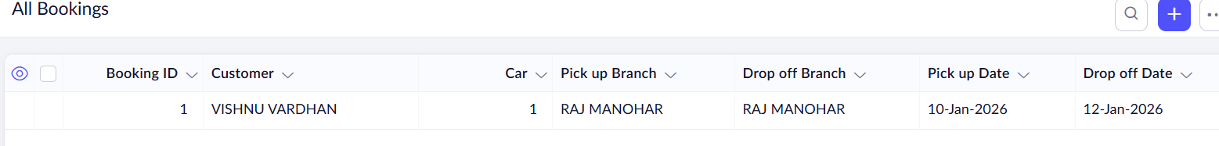
5.
